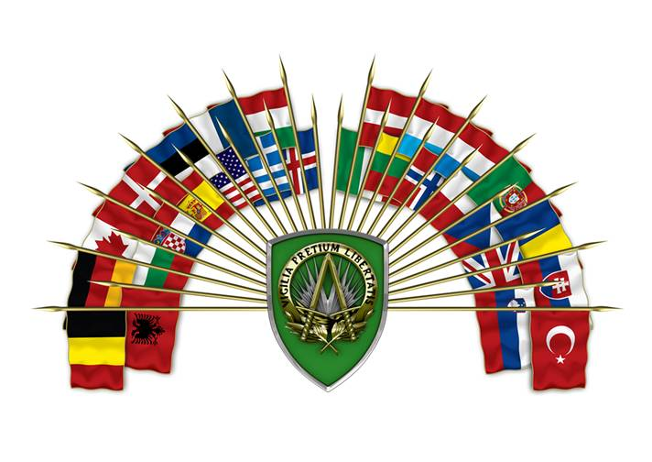

SHAPE INTERNATIONAL SCHOOLS
BELGIAN Section
Belgian Kindergarten (French speaking)
Phone # DSN: 423-5723 CIV:065445723
Address Avenue de Zilnius 708
Ages 2 ½ -6 years

Belgian Elementary School (French speaking)
Phone # DSN: 423-5707 CIV:065445707
Address Avenue de Luxemburg Bldg 417
Ages 6 – 12 years 1st-6th grade

Belgian High School (French speaking)
Phone # DSN: 423-5708 CIV:065445708
Address Avenue de Luxemburg Bldg 416
Ages 12 – 18 years
Website: www.ei-shape.be

UNITED KINGDOM Section
British School (English speaking)
Phone # DSN: 423-5283 CIV:065445283
Address Avenue d’ Ankara Bldg 701
Ages 3-4 (08:55-12:00)
School 5-11 years
Website: www.britishschool-shape.sceschools.com

CANADIAN Section
Students are placed in French or English groups; however,
English students also take 40 minutes of French each day.
Phone # DSN: 423-5985 CIV: +32 65445985
Address Rue du Soleil Street Bldg 1b
Grades 1-8 *see flyer

GREEK Section
Greek After school program (Greek speaking)
Phone # DSN: 423-7675 CIV:065447675
Address Soleil Street Bldg 1G-4
Email: teg.Shape.2015@gmail.com
GERMAN Section
International Kindergarten (German speaking)
Phone # DSN: 423-6264 CIV:065446264
Address Avenue d’ Reykjavik Bldg 708
Ages 2 ½ -6 years

German School (German speaking)
Phone # DSN: 423-5704 CIV:065445704
Address Avenue d’ Ankara Bldg 702
Grades 1-12 (must be 6 by 31 Dec)

ITALIAN Section
Sezione Italiana (Italian speaking)
Phone # DSN: 423-5711 CIV:065445711
Address Bldg 710
Grades 1-5

NORWEIGEN Section
Norweigen School (Norweigen speaking)
Phone # DSN: 423-5713 CIV:0654457213
Address Bldg 727
Grades 1-10
Website:www.dnsshape.org

POLISH Section
Polish After school program
(Polish speaking)
Phone # DSN: 423-4037 CIV:065444037
Address Soleil Street Bldg 1G-5
Elementary, Middle School and High School

TURKISH Section
Turkish After school program
(Turkish speaking)
Phone # DSN: 423-4771 CIV: 065444771
Address Bldg 702
Grades 1-12
Email: venessa3850@Hotmail.com

Shape2day.com for more information on schools
School Liaison Officer: bonnie.t.cornelison.naf@mail.mil

